LPE2504 CREATIVE WRITING SKILLS
SEMESTER 1 – 2025/2026
LECTURE NOTES 3 – WEEK 9

WEEK 9

INTRODUCTION TO SHORT STORY

A short story should be read in one sitting (Edgar Allan Poe).

A short story is a fictional work of prose that is shorter in length than a novel. In contemporary fiction, a short story can range from 1,000 to 20,000 words, one that could be read within a brief span of time, and is self-contained.

Due to the shorter length, a short story usually focuses on one plot, one main character (with a few additional minor characters), and one central theme, whereas a novel can tackle multiple plots and themes, with a variety of prominent characters.

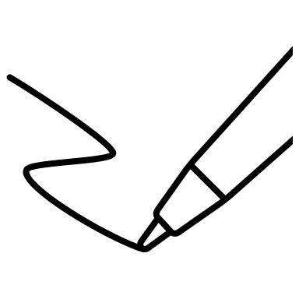
Activity 1: Identifying the Types of Short Stories
Match the types of short stories below with the given descriptions. You can refer to relevant websites for information.

Flash Fiction | Anecdote | Story Sequence | Frame Story
Vignette | Fable | Mini-saga | Feghoot

Type of Short Story: _______________
An anecdote is a type of storytelling about a real person and/or incident. This short account of something is interesting as well as amusing. Often, anecdotes are used to illustrate or support a point in an essay, article, or chapter. They are very short, but have no specific limits.

Type of Short Story: _______________
It features anthropomorphic creatures (usually animals, but also mythical creatures, plants, inanimate objects, or forces of nature) telling a story with a moral which is most of the time revealed at the end. The most well-known example of a fable would be the stories in Aesop’s Fables.

Type of Short Story: _______________
With humour form as the most essential part of its storytelling and short length enough to lead the piece with the pun, Feghoot is a story pun or a poetic story joke - type of short story.
Type of Short Story: _______________

This short story has no widely accepted length, but has a debated cap of between 500 and 1000 words. One quintessential example would be One Last Night at the Carnival before The Stars Go Out.

Type of Short Story: _______________
Also known as a frame tale or a nested narrative, it adopts a technique of placing a story within a story, for the purpose of introducing or setting the stage for a main narrative or a series of short stories. A few good examples of a frame story would be a flashback within a larger piece or a quest within a larger game environment.

Type of Short Story: _______________
This is an extremely short piece of literature. If you can manage to tell a story in exactly 50 words you can call it a mini saga. It is about saying a lot with a little.

Type of Short Story: _______________
When a group of short stories is put together to form a longer piece - it is called a story sequence. However, each story functions as a complete short story on its own. It is also called a short story cycle or a composite novel.

Type of Short Story: _______________
A vignette is a short piece that focuses on a single scene, character, idea, setting, or object. There is little emphasis on adhering to conventional theatrical or literary structure, or story development. It can be a stand-alone piece or part of a larger work.

Activity 2: Exploring the Characteristics of A Short Story
Describe the characteristics of a short story below by referring to the following websites:
chrome-extension://efaidnbmnnnibpcajpcglclefindmkaj/https://schools.ednet.ns.ca/avrsb/070/rsbennett/eng12/coursematerials/shortstories/STSTORY%20intro.pdf
chrome-extension://efaidnbmnnnibpcajpcglclefindmkaj/https://www.jetir.org/papers/JETIR1903K93.pdf

.

Short

Concise

Single Theme

Readers' Experiences

Short stories, ranging from mini sagas to flash fictions, offer a diverse array of literary experiences in condensed forms. Characterised by brevity and impactful storytelling, these compact narratives captivate readers with their ability to distil rich themes into concise, memorable expressions.

LITERARY ELEMENTS OF A SHORT STORY

Literary elements are several specific methods used by writers to convey their message. The 5 main literary elements in literature are theme, plot, character, setting and tone. Below are the descriptions for the literary elements.

THEME
Theme is defined as a main idea or an underlying meaning of a literary work, which may be stated directly or indirectly. Major and minor themes are two types of themes that appear in literary works.
A major theme is an idea that a writer repeats in his literary work, making it the most significant idea in the work.
A minor theme, on the other hand, refers to an idea that appears in a work briefly, giving way to another minor theme.
Some of the common themes that you can find in short stories are love, friendship, filial piety and tragedy.

Examples:

The Hare and the Tortoise from The Aesop’s Fables portrays the theme of arrogance and perseverance.

The Lottery, a short story from Shirley Jackson explores on the themes of superstition and cruelty.

While Edgar Allan Poe writes about the themes of guilt and madness in his short story The Tell-Tale Heart.

PLOT
Plot is a literary term used to describe the events that make up a story, or the main part of a story. These events relate to each other in a pattern or a sequence.
The structure of a short story depends on the organisation of events in the plot of the story. Thus, plot is known as the foundation of a story, around which the characters and settings are built.
Freytag’s Pyramid explains about the five primary elements in a plot:

Inciting Incident / Crisis
Exposition
Rising Action
Climax
Falling Action
Resolution

- Exposition or introduction
Normally found at the beginning of a story, this is where characters and setting are introduced and established. The conflict or main problem is introduced as well.
- Rising action
Rising action occurs when a series of events build up to the conflict. The main characters are established by the time the rising action of a plot occurs, and at the same time, events begin to get complicated. It is during this part of a story that excitement, tension, or crisis is encountered.
- Climax
This is the turning point of the story, meant to be the moment of highest interest and emotion, leaving the reader wondering what is going to happen next.
- Falling action
In this winding up stage of the story, events and complications begin to resolve. The results of the actions of the main characters are stated.

- Resolution
This is part of the story where the main conflicts are resolved, and the characters’ storylines are completed. This is also where any major loose ends are tied up and subplots with minor characters are concluded.

CHARACTER
A character can be any person, a figure, an inanimate object, or animal. There are different types of characters, and each serves its unique function in a story or a piece of literature.
The primary role of characters is to advance the plot, with numerous narratives featuring various character types. Essential to every story are main characters, individuals who exert the most significant influence on the plot or are profoundly impacted by the events unfolding in the narrative.
A character in a short story can be made up of different types of characters. The following are the types of the characters commonly found in short stories:
Protagonist | Antagonist
Every story has a protagonist, the main character, who creates the action of the plot and engages readers, arousing their empathy and interest.  The protagonist is often a hero or heroine of the story, as the whole plot moves around him or her. | An antagonist is a bad guy, or an opponent of the protagonist or the main character.  The action in the story arises from a conflict between the protagonist and the antagonist.  The antagonist can be a person, an inanimate object, an animal, or nature itself.

Dynamic character | Static character
A dynamic character changes during the course of a novel or a story.  This change in character or his/her outlook is permanent. That is why sometimes a dynamic character is also called a “developing character.” | A static character remains the same throughout the whole story.  Even the events in a story or novel do not change character’s outlook, perceptions, habits, personality, or motivations.
Round character | Flat character
The round characters are well-developed and complex figures in a story.  They are more realistic, and demonstrate more depth in their personalities.  They can make surprising or puzzling decisions, and attract readers’ attention.  There are many factors that may affect them, and round characters react to such factors realistically. | A flat character usually reveals one or two personality traits only.  It is also referred to as “one-dimensional” or “two-dimensional” character.  A flat character usually conforms to a stereotype, lacks of multi-faceted personality and does not undergo any internal conflict or character development in the short story.

Activity 2: Identifying the Types of Short Stories
Based on the given Short Stories and Name of Characters, identify the types of character each character conforms to by completing the table below.
Short Story | Name of Character | Types of Character
Cinderella | Stepsisters
Hansel and Gretel | Gretel
Snow White | Huntsman
The Ant and the Grasshopper | Grasshopper
The Crow and the Pitcher | Crow

SETTING
The setting of a piece of literature is the time and place in which the story takes place.
The definition of setting can also include social statuses, weather, historical period, and details of immediate surroundings.
Settings can be real or fictional, or a combination of both real and fictional elements.

For example:
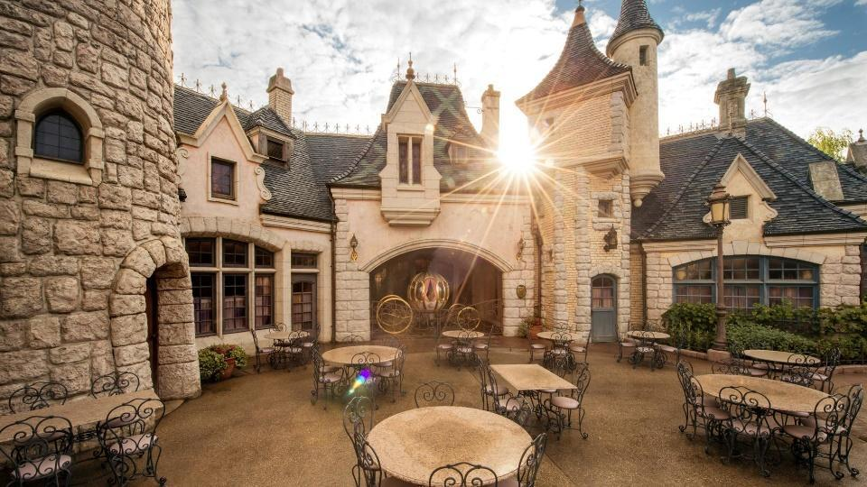
The fairytale Cinderella or Cendrillon is originally written by Charles Perrault. Because it is originally written in French in 1950s, it would be plausible to think that the story takes place in France in 1950s.


Whereas Lagenda Puteri Gunung Ledang, a local folklore, takes place in the 1480s, during the reign of Sultan Mahmud Shah, the eight Sultan of Melaka. The main place settings are Melaka and Mount Ledang.

The setting provides the backdrop to the story and helps to create the mood when readers read the short story.

TONE
Tone is an attitude of a writer toward a subject or an audience.

Tone is generally conveyed through the choice of words, or the viewpoint of a writer on a particular subject. It can also be established through imagery, sentence construction, word order and also through a viewpoint a character focuses on.

Every written piece comprises a central theme or subject matter. The manner in which a writer approaches this theme and subject is the tone. The tone can be formal, informal, serious, comic, sarcastic, sad, or cheerful, or it may be any other existing attitude.

Activity 3: Exploring the Literary Elements of A Short Story
Read the following story and answer the questions that follow.
The Good Fairy, And the Tale of How She Chose One to Speak for All

‘You can have three wishes,’ said the Good Fairy to Brian. He thought and thought and thought, then said: ‘Peace on earth for evermore.’ ‘Granted,’ said the Good Fairy. Brian thought again. ‘And no more disease or death!’ ‘Granted,’ said the Good Fairy. ‘And a chocolate bar!’
Brian was four.

- What type of short story is the above example?
______________________________________________________________

- How many characters are there in the short story?
______________________________________________________________

- What do you think is the tone of the short story? Why?
__________________________________________________________________________________________________________________________________________________________________________________________

- What do you think is the setting of the short story? Why?
__________________________________________________________________________________________________________________________________________________________________________________________

- What is the climax of the short story? Why?
__________________________________________________________________________________________________________________________________________________________________________________________

- What is the theme of the short story?
______________________________________________________________

Activity 4: Exploring the Literary Elements of A Short Story
Read the following story and answer the questions that follow.

"Clean out your desk. You're fired. I want you out of here by the end of the day," Lawrence shouted at Miguel Diaz, a low-level machine operator. "But, Mr. Roberts, sir, may I have two more weeks to find another job? I have kids," responded Miguel with tears in his eyes. Lawrence Roberts laughed, "Yeah, a lot of kids are starving in Asia too, and they aren't getting two more weeks either. End of the day, Me-gail!" Mr. Roberts replied, deliberately mispronouncing Miguel's name. Miguel went to clean out his desk and Lawrence Roberts went to lunch.
While driving to an expensive Italian restaurant in an expensive foreign car, Lawrence did not think much about Miguel. After seeing Miguel eat a bagel on the job earlier in the week, Lawrence assumed that Miguel was lazy and gluttonous. That was all he needed. Lawrence enjoyed firing him, and then he thought to move on with his life. That was before he looked to the right to make a turn and noticed his dead brother sitting in the seat beside him.
"Ahhhhhh!" Lawrence screamed as the spectral form of his brother floated in the passenger side with his seatbelt ironically pulled over his chest. Lawrence swerved through the oncoming traffic, narrowly avoiding a collision with an SUV. He parked on the front lawn of a tanning booth parlor and jumped out. Lawrence continued screaming as he ran from the car, but the form pursued him. "Laaaaawrence, I'm still faster than you," the ghost brother said as he overtook Lawrence. Lawrence, out of breath, stopped and put his hands on his knees.
"OK, you win. What do you want? You want to shame me for not visiting you when you were sick. OK, I feel bad. I'm sorry. Is that what you want?" The ghost laughed, "No Lawrence, you fool. You are in a position to bring good to the world, and you are only bringing pain and sadness. Do you remember that man that you fired today?" Lawrence had to think. "Yes, Miguel Diaz. The man is lazy. All he does is sit around and eat," Lawrence said dismissively. His brother attempted to slap the back of his head but his hand passed through him. Lawrence felt an eerie chill. "Lawrence, you buffoon, that man was working through his lunch break, covering for someone else on a day that he wasn't even supposed to work. He's the hardest worker in the plant." Lawrence thought about it for a second and returned, "Well, whatever. What's done is done. He'll find another job." His brother grabbed Lawrence by the shoulders and they faded into an ethereal mist.

When Lawrence and his brother reappeared, they were inside of Miguel Diaz's home. He and his wife were sobbing at the table. "I worked so hard for that man. I put love into everything that I did, and he cast me out like a sock with a hole in it," Miguel confided in his wife. Lawrence was afraid to step out of the pantry. His ghostly brother told him, "Don't worry, Lawrence. They can't see or hear you. I want to show you something." The ghost took him to the top of the stairs where Miguel's three children were secretly listening to their parents. The oldest child had his arm around the middle child, who was quietly sobbing. The youngest child was holding his piggy bank. "That's what I wanted to show you, Lawrence," said the spirit. "He reminds me of you, Lawrence, he's going to offer that piggy bank to his father. Didn't you do the same thing when our father fell on hard times?"
Lawrence thought back to when he was a child, before his father started the successful factory, when his father had been laid off from his job. A twinkle appeared in Lawrence's eyes and his cold heart cracked. His brother grabbed him by the shoulders again and they faded away through time and space together.
When Lawrence reappeared, he was alone in his expensive luxury car in the parking lot of an expensive Italian restaurant. He heard the voice of his brother pass through the air, "It's not toooooo late…" and Lawrence started up the car. He raced back to the plant and caught Miguel just as he was about to drive out of the parking lot. Lawrence fish tailed his car around and blocked Miguel in his spot.
"Miguel, I'm sorry," Lawrence shouted as he ran at Miguel's car. "This plant needs people like you. People like you made this plant. This plant can only continue with people like you." Miguel looked suspiciously at the rich old man as he stuck his head in Miguel's passenger side window. "You hurt me, Mr. Roberts, but I do need this job." Lawrence smiled broadly. "Not as much as we need you, Miguel. How about we give you a promotion and double your salary?" Miguel put the car in park and turned off the ignition.
Three months later the plant was operating with greater efficiency and making more money than it ever had. Lawrence and Miguel bonded over lunch at a fancy Italian restaurant. They clinked their glasses together as they toasted to the past, present, and future. As Lawrence and Miguel cheered life, Lawrence felt an eerie chill around his shoulder. Lawrence found this chill comforting.

- What type of short story is the above example?
______________________________________________________________

- Which character is best described as the antagonist?
______________________________________________________________

- Is Miguel a dynamic or static character? Explain your answer.
__________________________________________________________________________________________________________________________________________________________________________________________

- Is Lawrence a round or flat character? Explain your answer.
__________________________________________________________________________________________________________________________________________________________________________________________

- What do you think is the tone of the short story? Why?
________________________________________________________________________________________________________________________________________________________________________________________________________________________________________________________

- What do you think are the setting (places) of the short story?
____________________________________________________________________________________________________________________________

- What is the climax of the short story? Why?
________________________________________________________________________________________________________________________________________________________________________________________________________________________________________________________

- What is the theme of the short story?
______________________________________________________________


Summary
A short story is a compact work of fiction distinguished by its brevity, typically ranging from a few hundred to a few thousand words. It revolves around a single plotline with a focused theme or idea, employing a range of language to convey a complete narrative within a confined space.

Characterised by a concise structure, short stories emphasise a clear beginning, middle, and end, often featuring a limited cast of characters and a well-defined conflict that propels the narrative forward. Atmosphere and setting play a crucial role, enhancing the reader's engagement through vivid descriptions.

Despite their succinct nature, short stories offer opportunities for meaningful character development, and their impact lies in the efficient exploration of a central theme or motif, leaving a lasting impression on the reader.

